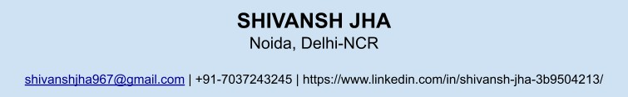

# Objective

Individual focused on achieving results and possessing robust skills in business analysis, data science and seeking to apply visualisation techniques and data-driven expertise at work. Bringing in basic knowledge of Python, Excel, and R to contribute effectively to the organisation.

# Skills

Data Visualization: Python, R, Excel Document Preparation: Latex

Certifications: Probability in Data Science, R, Excel for Data Science- Great Learning Academy, Business Analysis and Process Management- Coursera

Excel Job Simulation- JP Morgan Chase & Co.

# Education

University of Delhi | Bachelors in Mathematics(Honours) New Delhi | 2021- 2024 Cumulative GPA: 6/10

Relevant Coursework: Mathematics, Economics, Statistics, Latex, R

Delhi Public School | Senior Secondary (PCM) Bulandshahr | 2020- 2021 Percentage: 92%

Relevant Coursework: Physics, Chemistry, Mathematics, English, Physical Education

# Experience

NeuralTechSoft | Data Analyst Intern Mumbai | 07.2024-07.2024

* Prepared clean python codes for analysis of ﬁnances of the company on the basis of various variables given in the dataset.
* Worked with the team on various projects of clients, providing them a clear visualisation on their sales and other functions.
* Working primarily on libraries like Matplotlib, Seaborn and Pandas.

EICT Academy, IIT Kanpur | Intern Work from home | 07.2021-09.2021

* Edited the online notes and library books available on their website.
* Found out the errors and bugs present in the notes and PDFs for the students and provided them with a complete error and uncopied data for the curriculum.

# Volunteering Experience

**Fractals- The Mathematics Society**: Secretary-2022. Lead and organised the annual fest of Mathematics- Fundamenta 2023 which had a footfall of more than 500 participants.

**Drishyam- The Filmmaking and Photography Cell**: Coordinator- 2022. Lead the Content Team of the cell. Contributed in the annual exhibition of the cell during Pravah 2023.

# Interests

Photography: Capture monuments and scenic views of places that I visit. Travelling: Visit a new city every four months.